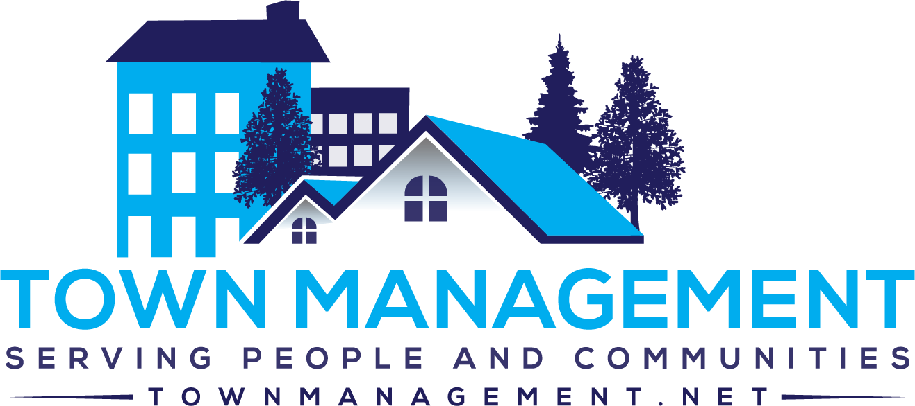
Villages At Westminster Association
PO Box 5010
Williamsburg, VA 23188

Welcome to Town Management!

Effective January 1, 2023, we will be the new managing agent for Villages at Westminster Association. Our office is in New Town at 4801 Courthouse Street, Suite 202, Williamsburg, VA 23188.

We look forward to assisting you and your association and have included information on how to make your association dues/assessments and your new account number as well.

It is important that your current contact information is on file. Please fill out the enclosed information form and return it to Town Management via email to admin@townmanagement.net or mail to:
Town Management, Villages at Westminster Association, P O Box 5010, Williamsburg, VA 23188.

A few items that may be helpful with the transition from Evernest:

- Please use the enclosed instructions on where to mail your January 1, 2023 assessment payments and how to set up online payments.

- Once you have made your 2022 payments to Evernest, please cancel any automatic payments to them.

Please let us know if there is anything that we can help you with. We look forward to assisting you.
Thank you and WELCOME!

Diane Clarcq, CMCA, AMS, PCAM
Community Association Manager
Town Management
(757) 565-6200
(757) 565-6291 (fax)
Diane@townmanagement.net

